LOCATION

The National School’s address: 31-547 Cracow, ul. Przy Rondzie 5
The seat of headquarters of the National School of Judiciary and Public Prosecution in Cracow is situated close to the Old Town, the business districts and the most important sightseeing attractions and historic monuments.
The National School is easily reached by car or public transport. The train station and central bus terminal are only a few minutes from the school on foot.
The National School is situated at the opposite side of Chopin Hotel Cracow. Parking places are available near the Chopin Hotel (pay parking) and before the District Court (free parking), which is also located in close distance from the School.

Transportation to/ from School
Balice Airport:
Krakow’s airport in Balice (The John Paul II International Airport Kraków-Balice) is situated 11 km west of the city centre.
Airport Information:
phone +48 12 295 58 00, +48 801 055 000, www.krakowairport.pl
City centre – Airport connections:
- By car - there are four different routes connecting the airport with the city centre. There is a secure, paid car park in front of the international terminal. For more parking information call: +48 12 295 30 65
- By taxi - you should expect to pay anything between 70-90PLN (depending on the time of the day, whether it is a weekday or weekend/public holiday). It takes approximately 30-40 min. to get to the centre of town. At the airport taxis are available from in front of the international terminal
- By bus - bus 292 has a few stops in the city centre, also by the Central Station (the Dworzec Główny Wschód stop between the railway and coach stations). The last stop is in front of the airport’s international terminal. It is worth remembering that the airport is situated outside the city boundaries and so the fares are slightly more expensive than those used in the city at PLN 3 – full fare, PLN 1.70 general discount, PLN 1.50 student discount. The bus journey takes 45 minutes. There are only one or two buses an hour therefore it is worth consulting the timetable when planning your journey. To get the National School you should get off the bus 292 at Rondo Mogilskie bus stop.
- By train - a fast train is available every half an hour, mostly from Platform 1 of the Central Railway Station. The train stops only at the Krakow-Balice station, which is approximately 200m away from the terminal. You can either walk the distance or take a free connecting bus which coordinates with the train timetable. The entire trip takes approximately 20 minutes and the fare is 6 PLN. Tickets are available at the Railway Station or from the ticket collector. They can be also purchased from the ticket machine in the airport terminal. For the train timetable click here.
- By mini-bus - provided by private companies Tomba and KrakowShuttle.
- Distance 15 km,
- Bus number 292
- Approx travel time 45 minutes by bus, 30 min by taxi
Main Railway Station: Dworzec Główny
- Distance 0,5 km
- Tram number: 5, 4, 10, 15, 9
- Travel time: 5 min by tram , 5-10 min by taxi
- Stop: Rondo Mogilskie
The Central Railway Station is situated in the city centre, approximately 10 minutes walk from the Market Square. Ticket offices are open between 5am and 11pm. You can check all train timetable on the PKP (Polish National Railway) website or by phone on +48 22 194 36 or +48 42 194 36 (these are Warsaw and Lodz area codes respectively).

Travelling to Krakow by car
Two main national roads cross in Krakow. These are national road no.7 (north-south) running from Gdansk to Chyzne, which is a part of the European road E77, and also a part of E40 which in Poland runs between Zgorzelec in the west and Korczowa in the east, partly via national road no. 4, motorway A4 and national road 77.
Below is the listing of the routes leading to border crossings (the names of Małopolska towns are underlined):
No. 4 – border crossing – Wrocław – Katowice – Chrzanów – Kraków – Wieliczka – Brzesko – Tarnów – Rzeszów – Przemyśl – (E40) Medyka / Szeginia – boarder crossing
No. 7 – Gdańsk – Elbląg – Warszawa – Radom – Kielce – Miechów – Kraków – Myślenice – Skomielna Biała – Chyżne / Trstena (border crossing)
No. 28 – Zator – Wadowice – Sucha Beskidzka – Maków Podhalański – Skomielna Biała – Rabka – Limanowa – Mszana Dolna – Nowy Sącz – Gorlice – Jasło – Krosno – Sanok – Przemyśl – (E40) Medyka / Szeginia (border crossing)
No. 49 – Nowy Targ – Białka Tatrzańska – Czarna Góra – Jurgów / Podspady (border crossing)

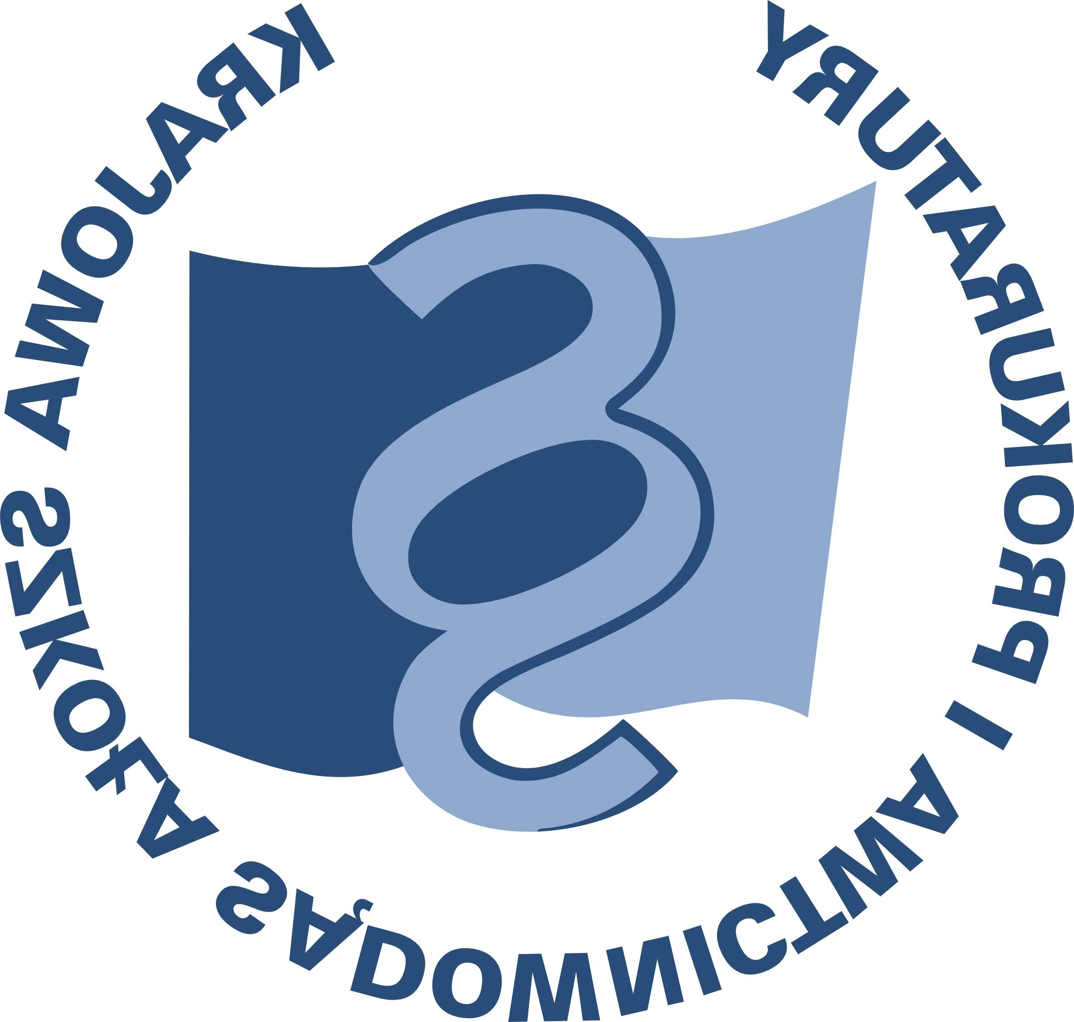
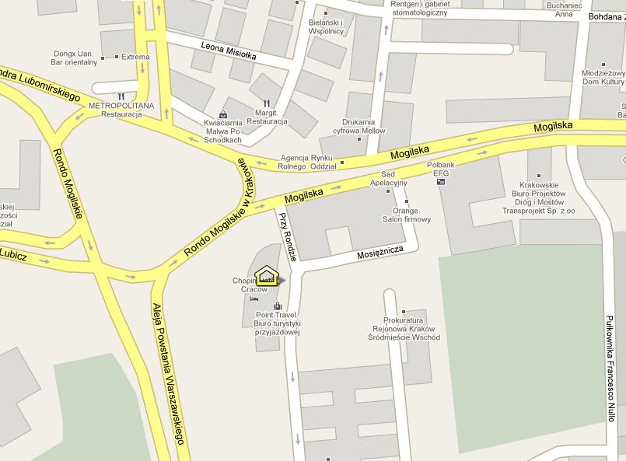
THE NATIONAL SCHOOL
OLD TOWN
SCHOOL
