We are pleased to launch the call for applications for the Exchange Programme 2016. This call covers the following activities:

- Short-term exchanges for judges/prosecutors and judicial trainers;
- Long-term training periods (Eurojust, CJUE and ECHR)

Please be informed that the call for study visits and specialised exchanges will be launched at a later stage.

Application procedure

As announced in the contact points meeting in May, this year’s call will be run through an online application form. The form can be found at: https://ejtn-exchange.azurewebsites.net/. The call will also be advertised through the EJTN website and social media channels.

We kindly ask you to direct your judiciary to the above URL to apply online to the Exchange Programme 2016.

Please find below some important points to consider when publishing the call at national level:

National Contact Point Reference Code:

The first page of the application form contains a specific field in which the applicants may enter a “reference code” provided by their National Contact Point (NCP). Adding the reference code to its space is the very first step to the application process, entered before clicking the ‘Apply’ button (see below):

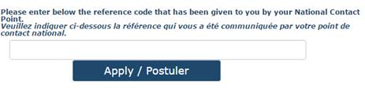

Pre SLOVENSKO na rok 2016 je referenčný kód: JASR2016EX

Supporting documents

Do sekcie dokumentov nemusíte nahrávať nič. Čestné prehlásenie o znalosti jazyka, ak ho už nemáte nahgraté, nahrávate na náš portal ja-sr.sk “Document Submission / Send documents” functionality of the application form (see below):
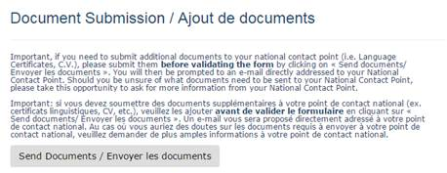

When clicking on the “send documents” button, applicants will automatically have an email message window created, with the ‘to’ field containing the NCP’s email address and the ‘subject’ field containing their name and the entered reference code if any. Applicants can then attach the relevant documents and send the email.

Selection procedure

Once the application period is over, national contact point will be able to proceed to the selection of your nationals through a dedicated website where all of the applications will be stored.

This website, specifically created for national contact points, will allow you to monitor the applications of your nationals, pre-select them, give them a priority order, allocate them to a reserve list, etc. It will constantly display the number of applications you can select according to what you had indicated in your partnership declaration 2016.

Deadlines

The following calendar is foreseen:

Deadline | Action | Actor
30 November 2015* | Application | Applicants
18 December 2015 | Pre-selection | National Contact Points
8 January 2016 | Allocation | EJTN secretariat

*Passed this deadline, the form will be no longer be accessible in order to allow contact points to proceed to the selection.

Financial conditions

Please be informed that the financial conditions governing EJTN activities will change from 1st January 2016 onwards as per the decision of the Steering Committee of 24-25 September 2015. Please find in attachment the updated EJTN Corporate Financial Policy. The Practical Guide to the Exchange Programme is currently being updated and will be circulated to all contact points and participants at the beginning of 2016.

